**Functional Document**

|  |  |
| --- | --- |
| **Application** | NGERP - Centra |
| **Service Bundle** | Integrations |
| **Service Request** | Import Activity (manual) |

**Description :**

User can manually import Activity using File Loader. Activity is used to identify and categorise the transaction purpose.

**Workflow Process :**

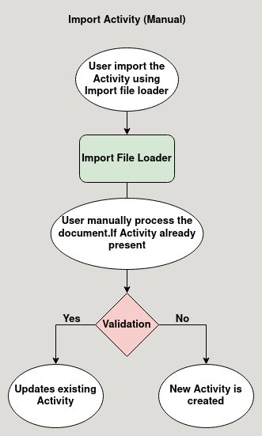

**Business Rules :**

* User can import Activity in file loader in HQ only.
* The activity file contains only two columns
  + Value
  + Name
* While importing a already present Activity it be updated.
* Value is used to search the activity and name is to identify the activity.
* After importing the activity in the file loader user process it manually in the import Activity temporary screen.
* After processing it will be loaded in the activity screen.